
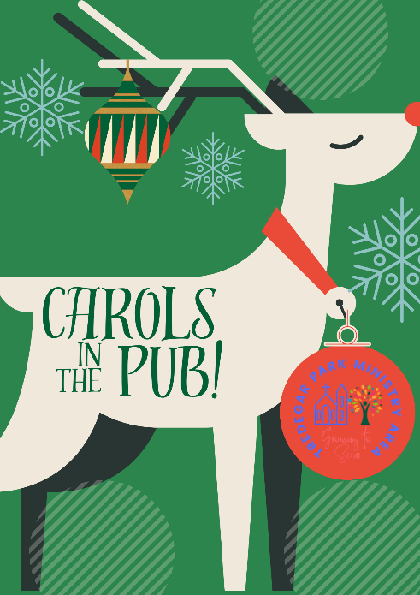

Welcome to
‘Carols in the pub’

Carol 1 - Ding Dong! Merrily On High

- Ding dong! Merrily on high,
in heav’n the bells are ringing;
Ding dong! Verily the sky
is riv’n with angels singing.
Gloria, Hosanna in excelsis….

- E’en so here below, below,
let steeple bells be swungen,
And i-o, i-o, i-o,
By priest and people sungen.
Gloria, Hosanna in excelsis…

3 Pray you dutifully prime
your matin chimes, ye ringers;
May you beautifully rhyme
your evetime song, ye singers.
Gloria, Hosanna in excelsis.

A welcome

Reading: Gospel of Mark, chapter 1, verses 1-3:

The good news of Jesus Christ—the Message! - begins here,
following to the letter the scroll of the prophet Isaiah. “Watch closely: I’m sending my preacher ahead of you; he’ll make the road smooth for you. Thunder in the desert! Prepare for God’s arrival! Make the road smooth and straight!”

Poem – The Angel Messenger!

The Birth of John the Baptist
First there was an angel,
who came to Zechariah
and said his wife Elizabeth
was going to have a child.
Zac did not believe him – “Elizabeth’s too old!”
But soon young baby John was born,
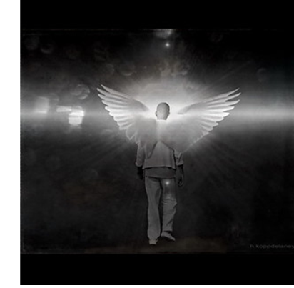
just like old Zac was told.

The Annunciation
Next the same archangel
came down to cousin Mary.
She found Archangel Gabriel
was really rather scary!
“Don’t worry,” said the angel,
“God hopes you’ll have his son
And call the baby Jesus
– he’ll be God’s chosen one.”

Reassuring Joseph
Quick! Send another angel,
put Joseph’s mind at peace!
It wasn’t hard for him to guess
the baby wasn’t his.
“Don’t worry,” said the angel,
“the baby is God’s Son.
This is the Messiah the prophets said would come.”
Carol 2 - O Little Town Of Bethlehem
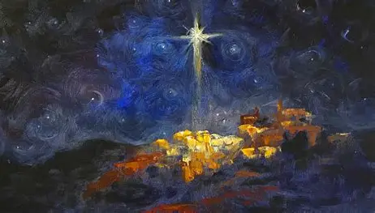
- O little town of Bethlehem
how still we see thee lie!
Above thy deep and dreamless sleep
the silent stars go by.
Yet in thy dark streets shineth
the everlasting Light;
The hopes and fears of all the years
are met in thee tonight.

2 For Christ is born of Mary;
and, gathered all above,
While mortals sleep, the angels keep
their watch of wond’ring love.
O morning stars, together
proclaim the holy birth,
And praises sing to God the King,
and peace to all on earth.

3 How silently, how silently, the wondrous gift is given!
So God imparts to human hearts
the blessings of His heaven.
No ear may hear His coming;
but in this world of sin,
Where meek souls will receive Him,
still the dear Christ enters in.

4 O holy Child of Bethlehem, descend to us we pray.
Cast out our sin and enter in, be born in us today.
We hear the Christmas angels
the great glad tidings tell:
O come to us, abide with us, our Lord Emmanuel.


Carol 3 - The Holly & The Ivy

- The holly and the ivy,
when they are both full grown,
Of all the trees that are in the wood,
the holly bears the crown:

O, the rising of the sun and the running of the deer,
The playing of the merry organ, sweet singing in the choir.

2 The holly bears a blossom,
as white as the lily flower,
And Mary bore sweet Jesus Christ
to be our sweet Saviour:

O, the rising of the sun and the running of the deer,
The playing of the merry organ, sweet singing in the choir.

3 The holly bears a berry, as red as any blood
And Mary bore sweet Jesus Christ
To do poor sinners good.

O, the rising of the sun and the running of the deer,
The playing of the merry organ, sweet singing in the choir.

4 The Holly bears a prickle, as sharp as any thorn
And Mary bore sweet Jesus Christ
on Christmas Day in the morn:

O, the rising of the sun and the running of the deer,
The playing of the merry organ, sweet singing in the choir.

5 The holly bears a bark, as bitter as any gall
And Mary bore sweet Jesus Christ
For to redeem us all.

O, the rising of the sun and the running of the deer,
The playing of the merry organ, sweet singing in the choir.
Carol 4 - Once In Royal David’s City

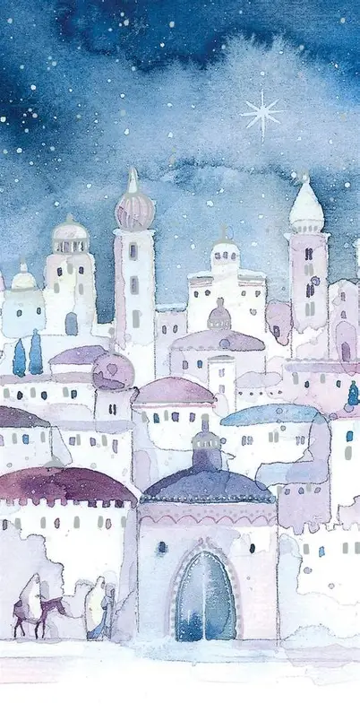
- Once in royal David’s city
Stood a lowly cattle shed,
Where a mother laid her baby
in a manger for His bed.
Mary was that mother mild,
Jesus Christ her little child.

2 He came down to earth from heaven,
Who is God and Lord of all,
And His shelter was a stable,
and His cradle was a stall;
With the poor and mean and lowly
lived on earth our Saviour holy.

3 For he is our childhood’s pattern,
Day by day like us he grew,
He was little weak and helpless,
tears and smiles like us he knew;
And he feeleth for our sadness
and he shareth in our gladness.

4 And our eyes at last shall see Him,
through His own redeeming love;
For that Child, so dear and gentle,
is our Lord in heaven above;
And He leads His children on
to the place where He is gone.

Reading from Luke’s Gospel, Chapter 2, v 1-7: the Nativity

About that time Caesar Augustus ordered a census to be taken throughout the Empire. This was the first census when Quirinius was governor of Syria.
Everyone had to travel to his own ancestral hometown to be accounted for. So Joseph went from the Galilean town of Nazareth up to Bethlehem in Judah, David’s town, for the census.
He went with Mary, his fiancée, who was pregnant.
While they were there, the time came for her to give birth. She gave birth to a son, her first-born.
She wrapped him in a blanket and laid him in a manger, because there was no room in the inn.

Carol 5 - Away In a Manger
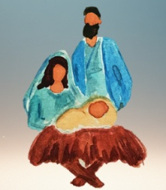
1 Away in a manger, no crib His bed,
The little Lord Jesus laid down His sweet head.
The stars in the bright sky looked down where He lay -
The little Lord Jesus, asleep on the hay.

2 The cattle are lowing, the Baby awakes,
But little Lord Jesus, no crying He makes.
I love Thee, Lord Jesus! Look down from the sky,
And stay by my side until morning is nigh.

3 Be near me, Lord Jesus, I ask Thee to stay
Close by me for ever, and love me, I pray.
Bless all the dear children in Thy tender care,
And fit us for heaven to live with Thee there.

Carol 6 - Silent night

- Silent night, holy night,
All is calm, all is bright
Round yon virgin mother and child!
Holy Infant so tender and mild,
Sleep in heavenly peace,
Sleep in heavenly peace.

2 Silent night, holy night,
Shepherds quake at the sight
Glories stream from heaven afar,
Heavenly hosts sing alleluia.
Christ the Saviour is born
Christ the Saviour is born.

3 Silent night, holy night,
Son of God, love's pure light
Radiant beams from Thy holy face,
With the dawn of redeeming grace,
Jesus, Lord, at Thy birth,
Jesus, Lord, at Thy birth.

Carol 7 - Joy To The World, The Lord Has Come

1 Joy to the world, the Lord is come;
Let earth receive her King!
Let every heart prepare Him room,
And heaven and nature sing,
And heaven and nature sing,
and heaven and heaven and nature sing.

2 Joy to the world! The Saviour reigns;
Let us our songs employ;
While fields and floods, rocks, hills and plains
Repeat the sounding joy,
Repeat the sounding joy, repeat,
Repeat the sounding joy.

3 No more let sin and sorrow grow
Nor thorns infest the ground
He comes to make, His blessings flow,
Far as the curse is found
Far as the curse is found
Far as, Far as, the curse is found.

4 He rules the world with truth and grace,
And makes the nations prove
The glories of His righteousness,
And wonders of His love
And wonders of His love,
And wonders, wonders of His love.
Poem — Good News
First to the Shepherds!
At first it was one angel
who flew above the hills.
The shepherds were quite terrified,
stood frozen – very still.
“Don’t worry,” said the angel,
“at what I’m going to say.
Good news I tell you!
God’s own Son has just been born today!”

Now All the Angels
Then many, many angels filled the night-time sky.
“Praise God who sends his Son down
from his heavenly home on high!”
The shepherds rushed to see the child
– he was lying in the hay,
Just like they’d heard the angel say.
Christ was born today!

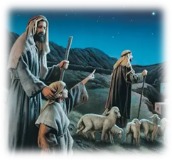
Carol 8 - While Shepherds Watched

1 While shepherds watched their flocks by night,
All seated on the ground,
The Angel of the Lord came down,
and glory shone around.

2 ‘Fear not,’ said he
(for mighty dread had seized their troubled minds),
‘Glad tidings of great joy I bring to you and all mankind.

3 ‘To you in David’s town this day, Is born of David’s line
A Saviour, who is Christ the Lord—
and this shall be the sign:

4 ‘The heavenly Babe you there shall find
To human view displayed
All meanly wrapped in swaddling bands,
and in a manger laid.’
5 Thus spake the Seraph, and forthwith
Appeared a shining throng
Of angels praising God on high,
who thus addressed their song:

6 ‘All glory be to God on high, and to the earth be peace;
Goodwill henceforth from heaven to men
begin and never cease.’

Carol 9 - The First Noel

1 The first Noel the angel did say,
Was to certain poor shepherds
in fields where they lay;
In fields where they lay, keeping their sheep,
On a cold winter’s night that was so deep.

2 They looked up and saw a star
Shining in the East, beyond them far;
And to the earth it gave great light,
And so it continued both day and night.

3 And by the light of that same star,
Three Wise Men came from country afar;
To seek for a King was their intent,
And to follow the star wherever it went.

4 This star drew night, to the northwest
O’er Bethlehem it took its rest
And there it did both stop and stay
Right over the place where Jesus lay.
Noel, Noel, Noel, Noel, Born is the King of Israel!

5 Then entered in, those wise men three
Full rev’ently upon their knee
And offered there in his presence
Their gold and myrrh and frankincense.
Noel, Noel, Noel, Noel, Born is the King of Israel!
6 Then let us all, with one accord,
Sing praises to our heavenly Lord,
Who hath made heaven and earth of naught,
And with His blood mankind hath bought.
Noel, Noel, Noel, Noel, Born is the King of Israel! (X2)

Reading - Matthew 2:1-3, 7-11 (TLB translation)
Jesus was born in the town of Bethlehem, in Judea, during the reign of King Herod.
At about that time some astrologers from eastern lands arrived in Jerusalem, asking, “Where is the newborn King of the Jews? for we have seen his star in far-off eastern lands and have come to worship him.” King Herod was deeply disturbed by their question, and all Jerusalem was filled with rumours. Then Herod sent a private message to the astrologers, asking them to come to see him; at this meeting he found out from them the exact time when they first saw the star. Then he told them, “Go to Bethlehem and search for the child. And when you find him, come back and tell me so that I can go and worship him too!”
After this interview the astrologers started out again. And look! The star appeared to them again, standing over Bethlehem. Their joy knew no bounds!
Entering the house where the baby and Mary, his mother, were, they threw themselves down before him, worshiping. Then they opened their presents and gave him gold, frankincense, and myrrh
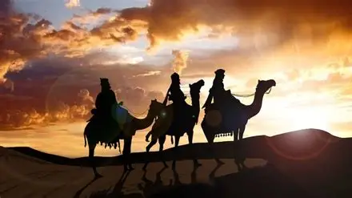
Carol 10 - We Three Kings
1 We three kings of Orient are
Bearing gifts we traverse afar
Field and fountain, moor and mountain
Following yonder star

O Star of wonder, star of night
Star with royal beauty bright
Westward leading, still proceeding
Guide us to thy Perfect Light

2 Born a King on Bethlehem’s plain
Gold I bring to crown Him again
King forever, ceasing never
Over us all to reign
O Star of wonder, star of night…..
3. Frankincense to offer have I
Incense owns a Deity nigh
Prayer and praising, all men raising
Worship Him, God most high
O Star of wonder, star of night…..

4 Myrrh is mine, its bitter perfume
Breathes of life of gathering gloom
Sorrowing, sighing, bleeding, dying
Sealed in the stone-cold tomb
O Star of wonder, star of night…..

5 Glorious now behold Him arise
King and God and Sacrifice
Alleluia, Alleluia
Earth to heav’n replies
O Star of wonder, star of night…..

Carol 11 - It Came Upon A Midnight Clear

- It came upon the midnight clear,
that glorious song of old,
From angels bending near the earth,
to touch their harps of gold.
‘Peace on the earth, goodwill to men,
from heaven’s all-gracious King!’
The world in solemn stillness lay
to hear the angels sing.

2 Still through the cloven skies they come,
with peaceful wings unfurled,
And still their heavenly music floats
o’er all the weary world;
Above its sad and lonely plains
they bend on heavenly wing,
And ever o’er its Babel sounds
the blessed angels sing.

3 For lo! The days are hastening on,
by prophet bards foretold,
When, with the ever circling years,
comes round the age of gold;
When peace shall over all the earth
its ancient splendours fling,
And the whole world send back the song
which now the angels sing!

Reading from 1 John Chapter 1, verses 1-4 (Message translation)
From the very first day, we were there, taking it all in -
we heard it with our own ears, saw it with our own eyes, verified it with our own hands The Word of Life appeared right before our eyes; we saw it happen!
And now we’re telling you in most sober prose that what we witnessed was, incredibly, this: The infinite Life of God himself took shape before us.
We saw it, we heard it, and now we’re telling you so you can experience it along with us, this experience of communion with the Father and his Son, Jesus Christ. Our motive for writing this is simply this: We want you to enjoy this too. Your joy will double our joy!

Carol 11 - Hark The Herald-Angels Sing
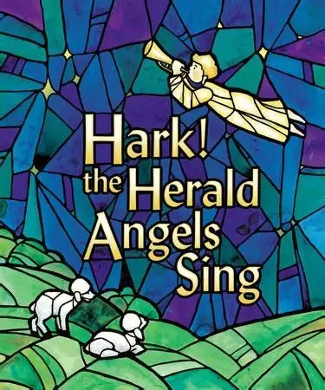
- Hark the herald-angels sing
glory to the new-born King,
Peace on earth and mercy mild,
God and sinners reconciled.
Joyful, all ye nations, rise,
join the triumph of the skies;
With th’angelic host proclaim,
Christ is born in Bethlehem:
Hark! The herald-angels sing
Glory to the new-born King.

2 Christ, by highest heaven adored,
Christ the everlasting Lord,
Late in time behold Him come,
offspring of a Virgin’s womb!
Veiled in flesh the Godhead see! Hail, the Incarnate Deity!
Pleased as Man with man to dwell, Jesus, our Emmanuel!
Hark! The herald-angels sing. Glory to the new-born King.

3 Hail, the Heaven-born Prince of Peace!
Hail, the Sun of Righteousness!
Light and life to all He brings,
ris’n with healing in His wings.
Mild, He lays His glory by,
born that we no more may die,
Born to raise the sons of earth,
born to give them second birth:
Hark! The herald-angels sing. Glory to the new-born King.

Other Christmas songs

Jingle Bells
Dashing through the snow
In a one-horse open sleigh
Over the fields we go
Laughing all the way.
Bells on bob-tail ring
Making spirits bright
What fun it is to ride and sing
A sleighing song tonight.

chorus:
Jingle bells, jingle bells
Jingle all the way,
Oh what fun it is to ride
In a one-horse open sleigh, O
Jingle bells, jingle bells
Jingle all the way,
Oh what fun it is to ride
In a one-horse open sleigh.

(repeat all)

Twelve Days of Christmas
On the first day of Christmas my true love sent to me
a partridge in a pear tree.

On the second day of Christmas, my true love sent to me
Two turtle doves,
and a partridge in a pear tree.

On the third day of Christmas, my true love sent to me
Three French hens,
Two turtle doves,
And a partridge in a pear tree.

On the fourth day of Christmas, my true love sent to me
Four calling birds,
Three French hens,
Two turtle doves,
And a partridge in a pear tree.

On the fifth day of Christmas, my true love sent to me
Five golden rings,
Four calling birds,
Three French hens,
Two turtle doves,
And a partridge in a pear tree.

On the sixth day of Christmas, my true love sent to me
Six geese a-laying,
Five golden rings,
Four calling birds,
Three French hens,
Two turtle doves,
And a partridge in a pear tree.

On the seventh day of Christmas, my true love sent to me
Seven swans a-swimming,
Six geese a-laying,
Five golden rings,
Four calling birds,
Three French hens,
Two turtle doves,
And a partridge in a pear tree.

On the eighth day of Christmas, my true love sent to me
Eight maids a-milking,
Seven swans a-swimming,
Six geese a-laying,
Five golden rings,
Four calling birds,
Three French hens,
Two turtle doves,
And a partridge in a pear tree.

On the ninth day of Christmas, my true love sent to me
Nine ladies dancing,
Eight maids a-milking,
Seven swans a-swimming,
Six geese a-laying,
Five golden rings,
Four calling birds,
Three French hens,
Two turtle doves,
And a partridge in a pear tree.

On the tenth day of Christmas, my true love sent to me
Ten lords a-leaping,
Nine ladies dancing,
Eight maids a-milking,
Seven swans a-swimming,
Six geese a-laying,
Five golden rings,
Four calling birds,
Three French hens,
Two turtle doves,
And a partridge in a pear tree.

On the eleventh day of Christmas, my true love sent to me
Eleven pipers piping,
Ten lords a-leaping,
Nine ladies dancing,
Eight maids a-milking,
Seven swans a-swimming,
Six geese a-laying,
Five golden rings,
Four calling birds,
Three French hens,
Two turtle doves,
And a partridge in a pear tree.

On the twelfth day of Christmas, my true love sent to me
Twelve drummers drumming,
Eleven pipers piping,
Ten lords a-leaping,
Nine ladies dancing,
Eight maids a-milking,
Seven swans a-swimming,
Six geese a-laying,
Five golden rings,
Four calling birds,
Three French hens,
Two turtle doves,
And a partridge in a pear tree!

We wish you a Merry Christmas
We wish you a merry Christmas
We wish you a merry Christmas
We wish you a merry Christmas and a happy new year
Good tidings we bring to you and your kin
We wish you a merry Christmas and a happy new year
Oh, bring us some figgy pudding
Oh, bring us some figgy pudding
Oh, bring us some figgy pudding
And bring it right here

Good tidings we bring to you and your kin
We wish you a merry Christmas and a happy new year
We won't go until we get some
We won't go until we get some
We won't go until we get some
So bring it right here

Good tidings we bring to you and your kin
We wish you a merry Christmas and a happy new year
We all like our figgy pudding
We all like our figgy pudding
We all like our figgy pudding
With all its good cheers

Good tidings we bring to you and your kin
We wish you a merry Christmas and a happy new year
We wish you a merry Christmas
We wish you a merry Christmas
We wish you a merry Christmas and a happy new year

