

The Holy Eucharist

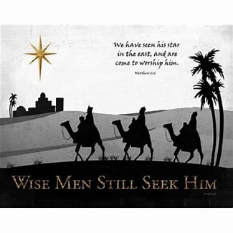
Epiphany to Candlemas
Welcome to Church

We hope you enjoy our service today.
Visiting members of Christian churches are welcome to receive Holy Communion. Adults and children who are not baptised are invited to the altar to receive a blessing during Communion. If you would like a blessing, please keep your hands lowered or bring your service booklet with you.

If you are new to church, please ask for a ‘New to Church booklet which will explain the service in a little more detail. Please also make yourself known to the officiating Priest at the end of the service, we would love to meet you.

Accessibility
During the service, please feel free to stand, kneel or sit as you feel comfortable. Indications of suggested posture and actions are included, in [blue], throughout this booklet. There is a visual timetable on the back page. Responses for the congregation can be found in bold.

If you would like a gluten free wafer, or have any additional needs, please ask one of our welcome team when you arrive.

Please leave this booklet behind at the end of the service.
We are glad you are here.
We want to get to know you.
We want you to know us.
We know God loves us all.
We don’t wish you to hide who you are.
We hope you will want to belong.
We welcome the gifts and talents you bring.

THE STRUCTURE OF THE SERVICE

1 1. The Gathering Page 4
This is space to come together, and to prepare ourselves, to encounter God in worship, the words of scripture and in the receiving the sacrament.
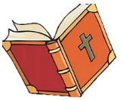
2. The Proclamation of the Word Page 7
When the bible is read aloud in church (words are also printed in the notice sheet), on a Sunday a sermon is also usually preached.

3. The Intercessions Page 10
A time of prayer, when we intercede to God, for ourselves and on behalf others, for the needs of our community and the world.
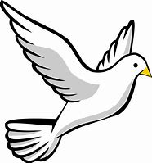
4. The Peace Page 11
As we prepare to receive communion, we receive God’s peace and immediately share it with the gathered community; setting aside any differences we may have before we approach the Lord’s table.

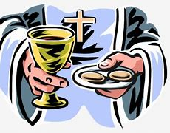
5. The Thanksgiving Page 12
The priest leads the congregation in prayers of thanksgiving, for God’s gifts to us and in particular God’s gift of Jesus, recalling the last supper, Christ’s death on the cross and his resurrection.

- Eucharistic Prayer 4 Page 12

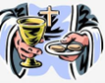
6. The Communion Page 17
Baptised members of the gathered community are invited to approach the altar rail and share in Holy Communion, receiving consecrated bread and wine. For those with a mobility disability, the priest will take Communion to the seat. Non-baptised members are invited to receive a blessing from the Priest at this time.
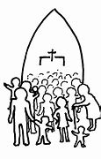
7. The Sending Out Page 18
The conclusion of the service during which the gathered community are sent out to into the world in God’s service, to share God’s love and peace.

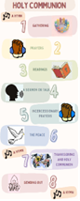

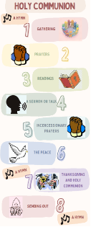
Visual Timetable - Page 20

1 The Gathering
_____________________________________________________

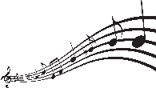 OPENING HYMN

[STAND]
In the name of the Father, and of the Son,
and of the Holy Spirit. Amen.

The Lord of glory be with you.
The Lord bless you.

Words of introduction may be used.

Father of glory, holy and eternal,
look upon us now in power and mercy.
May your strength overcome our weakness,
your radiance transform our blindness,
and your Spirit draw us to that love
shown and offered to us by your Son,
our Saviour Jesus Christ. Amen.


A CHANCE TO BRING OUR SINS BEFORE GOD

[SIT or KNEEL]
Lord, have mercy. Lord, have mercy.
Christ, have mercy. Christ, have mercy.
Lord, have mercy. Lord, have mercy.

Dear friends, the light of Jesus shines out as he calls all nations and peoples to his dawning brightness. Let us bring the darkness of our sin to be transformed by the light of Christ.

Silence.

Let us bring our sins to our Heavenly Father:
Heavenly Father,
we have sinned in thought, word and deed,
and have failed to do
what we ought to have done.
We are sorry and truly repent.
For the sake of your Son Jesus Christ
who died for us,
forgive us all that is past
and lead us in his way
to walk as children of light. Amen.

Almighty God, who forgives all who truly repent,

have mercy on you and set you free from sin,
strengthen you in goodness
and keep you in eternal life;
through Jesus Christ our Lord. Amen.

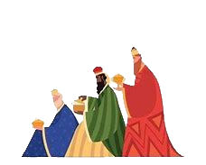
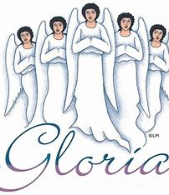
GLORIA IN EXCELSIS is said or sung

[STAND]
Glory to God in the highest,
and peace to his people on earth.
Lord God, heavenly King,
Almighty God and Father,
we worship you, we give you thanks,
we praise you for your glory.
Lord Jesus Christ, only Son of the Father,
Lord God, Lamb of God,
you take away the sin of the world:
have mercy on us;
you are seated
at the right hand of the Father:
receive our prayer.
For you alone are the Holy One,
you alone are the Lord,
you alone are the Most High,
Jesus Christ, with the Holy Spirit,
in the glory of God the Father. Amen.


THE COLLECT OF THE DAY

The Priest introduces a period of silence with the words:

Let us pray in the light of the glory of the Lord.

The Collect can be found on the notice sheet and is said by the priest, all respond: Amen.

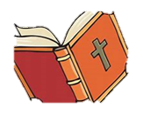
2. The Proclamation of the Word
_____________________________________________________

A copy of the readings can be found on the notice sheet (please ask if you need a large print copy).

[SIT]

The First Reading

At the end the reader says:
Either: This is the word of the Lord.
Thanks be to God.

or: Hear what the Spirit is saying to the church.
Thanks be to God.

A Psalm or Canticle
The psalm can be found on the weekly notice sheet, it may include a response for the congregation. Please check the sheet for details.

The Second Reading
At the end the reader says:
Either: This is the word of the Lord.
Thanks be to God.

or: Hear what the Spirit is saying to the church.
Thanks be to God.


THE GOSPEL READING

[STAND]

The Gospel Acclamation
The gospel acclamation and reading can be found on the notice sheet.
The priest or deacon read the acclamation and the congregation responds.

The Gospel

The reader says:
Listen to the Gospel of Christ according to Saint....
Glory to you, O Lord.

After the Gospel:
This is the Gospel of the Lord.
Praise to you, O Christ.

The Gospel Acclamation may be repeated.


THE SERMON

[SIT]

AN AFFIRMATION OF THE FAITH - The Apostles’ Creed

[STAND]

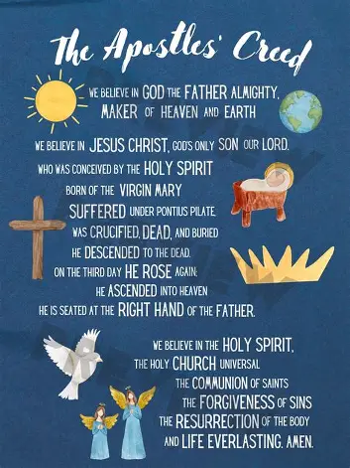
I believe in God, the Father almighty, creator of heaven and earth.

I believe in Jesus Christ, his only Son, our Lord.

He was conceived by the power of the Holy Spirit and born of the Virgin Mary.

He suffered under Pontius Pilate,
was crucified, died, and was buried.

He descended to the dead.

On the third day he rose again.
He ascended into heaven and is seated at the right hand of the Father.
He will come again to judge the living and the dead.

I believe in the Holy Spirit, the holy catholic Church,
the communion of saints, the forgiveness of sins, the resurrection of the body and the life everlasting.

Amen.

3 The Intercessions

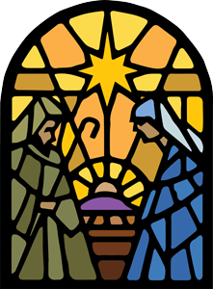
[SIT or KNEEL]

After each intercession:

Either: Lord, in your mercy,
hear our prayer.

or: Let us pray to the Lord.
Lord, have mercy.

or: Lord of our light and salvation,
hear us and answer our prayer.

After the final petition:
Merciful Father,
accept these prayers
for the sake of your Son,
our Saviour Jesus Christ.
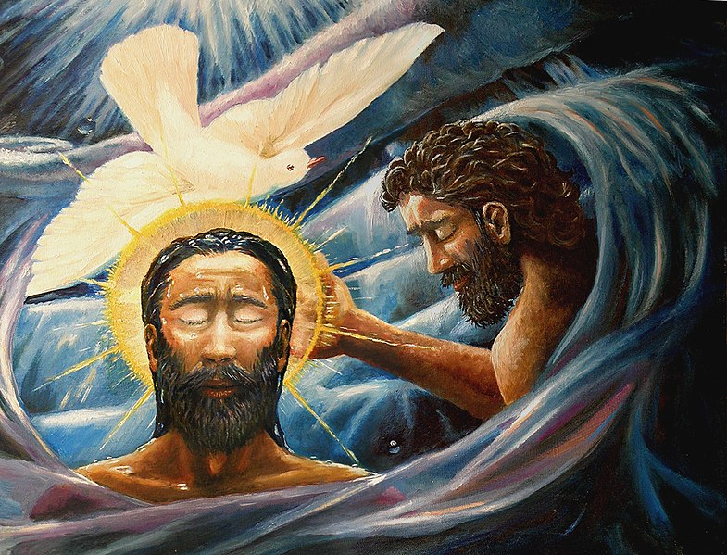
Amen.

4. The Peace

[STAND]
___________________________________________

Either: Our Saviour Christ is the Prince of peace;
of the increase of his government
and of peace there will be no end.

or: Christ is our peace. If anyone is in Christ,
there is a new creation.
The old has passed away:
behold, the new has come.

or: Let the peace of Christ rule in our hearts;
to this peace we are called
as members of one body.
God's love has been poured into our hearts
through the Holy Spirit he has given us.

or: In the tender compassion of our God
the dawn from heaven will break upon us,
to shine on those who live in darkness,
under the shadow of death,
and to guide our feet into the way of peace.

or other suitable words may be said.

The peace of the Lord be with you always.
And also with you.

A sign of peace may be exchanged.



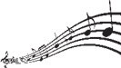
OFFERTORY HYMN

5 The Thanksgiving
_____________________________________________________
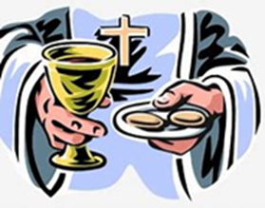
The priest takes the bread
and the cup and says:

We celebrate together
the gifts and grace of God.
We take this bread, we take this wine
to follow Christ's example
and obey his command.

EUCHARISTIC PRAYER 4

The Lord be with you. or The Lord is here.
And also with you. His Spirit is with us.

Lift up your hearts.
We lift them to the Lord.

Let us give thanks to the Lord our God.
It is right to give our thanks and praise.

It is indeed right, it is our duty and our joy
at all times and in all places to give you thanks, holy Father, all-powerful and everliving God,
through Jesus Christ our Lord.

Either: Because by the leading of a star
you have revealed him to the world
in human form,
that in following him
we are brought out of darkness
into his marvellous light.

or: When he was baptized by John,
he was revealed as your beloved Son,
the One on whom your favour rests.
Anointed by your Spirit as the Christ,
he went forth to do his saving work.

or: And now we give you thanks
because through the Word made flesh
your glory shines through the world.
In him the new creation has been revealed,
a new light has dawned
and all the nations are brought out of darkness.

or: Who shares your eternal splendour
and was presented in the Temple.
He was revealed by the Spirit
as the glory of Israel
that all peoples might find in him
the light of the world.


And so with the hosts of angels
and all the company of heaven
we proclaim the glory of your name
and join in their unending hymn of praise:

Holy, holy, holy Lord,
God of power and might,
heaven and earth are full of your glory.
Hosanna in the highest.

Blessed is he who comes in the name of the Lord. Hosanna in the highest.

All praise and thanks to you, true and living God,
Creator of all things, Giver of life.
You formed us in your own image;
but we have marred that image
and fall short of your glory.
We give you thanks
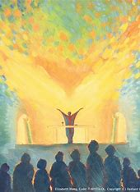
that you sent your Son to share our life;
you gave him up to death that the world might be saved, and you raised him from the dead
that we might live in him and he in us.

Sanctify with your Spirit
this bread and wine,
your gifts to us,
that they may be for us
the body and blood
of our Saviour Jesus Christ.

On the night he was betrayed, he took bread,
and when he had given thanks
he broke it and gave it to his disciples, saying,
Take, eat; this is my body which is given for you:
do this in remembrance of me.

In the same way after supper he took the cup,
and when he had given thanks
he gave it to them, saying,
Drink from this, all of you, for this is my blood of
the new covenant which is shed for you and for many for the forgiveness of sins:
do this as often as you drink it
in remembrance of me.

Great is the mystery of faith:
Christ has died. Christ is risen.
Christ will come in glory.

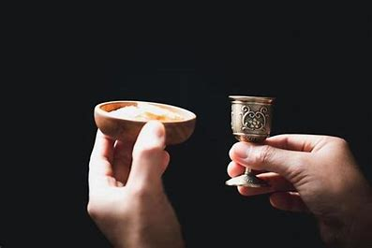
As he has commanded us, Father,
we remember Jesus Christ, your Son.
Proclaiming his victorious death,
rejoicing in his resurrection
and waiting for him to come in glory
we bring to you this bread, this cup.

Accept our sacrifice of thanks and praise.
Restore and revive your people, renew us and all for whom we pray with your grace and heavenly blessing,
and at the last receive us with all your saints
into that unending joy promised by your Son, Jesus Christ our Lord.

Through him, with him, in him, in the unity of the Holy Spirit all honour and glory are yours, almighty Father, for ever and ever. Amen.

Silence.

[SIT or KNEEL]


THE LORD’S PRAYER

In Christ we have received the Spirit of adoption as children of God, and so we dare to pray:
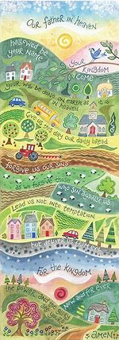
Our Father who art in heaven,
hallowed be thy name,
thy kingdom come, thy will be done,
on earth as it is in heaven.
Give us this day our daily bread.
And forgive us our trespasses as we forgive those who trespass against us.
And lead us not into temptation,
but deliver us from evil.
For thine is the kingdom,
the power and the glory,
© Hannah Dunnett for ever and ever. Amen.

or: Let us pray with confidence to the Father:
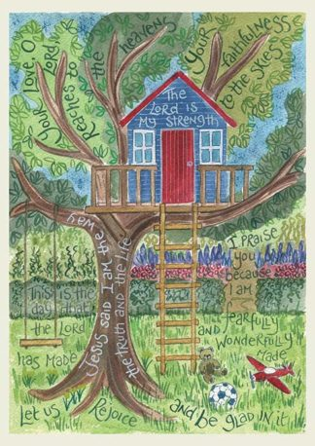
Our Father in heaven,
hallowed be your name,
your kingdom come,
your will be done,
on earth as in heaven.
Give us today our daily bread.
Forgive us our sins
as we forgive those who sin against us. © Hannah Dunnett
Save us from the time of trial
and deliver us from evil.
For the kingdom, the power
and the glory are yours,
now and for ever. Amen.

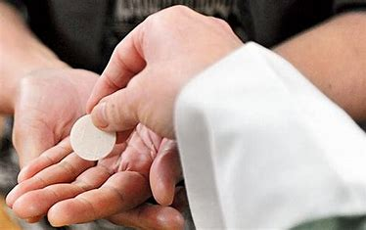
6. The Communion
_____________________________________________________

The priest breaks the bread.

We break this bread to share in the body of Christ.
Though we are many, we are one body
for we all share in one bread.

Either: Jesus, Lamb of God:
have mercy on us.
Jesus, bearer of our sins:
have mercy on us.
Jesus, redeemer of the world:
give us your peace.

or: Lamb of God,
you take away the sins of the world:
have mercy on us.
Lamb of God,
you take away the sins of the world:
have mercy on us.
Lamb of God,
you take away the sins of the world:
grant us peace.

The priest invites the people to communion:

God’s holy gifts for God’s holy people.
Jesus Christ is holy,
Jesus Christ is Lord,
to the glory of God the Father.

The priest and people receive communion or a blessing.

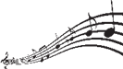
During communion hymns may be sung.

After the communion a period of silent reflection is kept ending with a Collect Prayer.

Notices may be given.
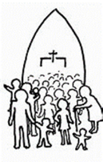

7. The Sending Out

[STAND]
_____________________________________________________
Give thanks to the Lord for he is gracious:
his love is everlasting.

We thank you, Father,
for feeding us
with the body and blood of your Son
in this holy sacrament,
through which we are assured
of the hope of eternal life.
We offer ourselves to you
as a living sacrifice.
Keep us in the fellowship of his body,
the Church,
and send us out in the power of your Spirit
to live and work to your praise and glory. Amen.

The Lord be with you.
And also with you.

Either: Christ the Son of God gladden your hearts
with the good news of his kingdom.

or: May God, whose Holy Spirit came upon the beloved Son at his baptism in the River Jordan,
pour out his gifts on you who have come to the waters of new birth.

or: May God the Father, who led the Wise Men
by the shining of a star to find the Christ,
the Light from Light, lead you in your pilgrimage
to find the Lord. Amen.

May God who has delivered us
from the dominion of darkness
give us a place with the saints in light
in the kingdom of his beloved Son. Amen.

May the light of the glorious gospel of Christ
shine in your hearts and fill your lives
with his joy and peace. Amen.

And the blessing of God almighty,
the Father, the Son, and the Holy Spirit,
be among you and remain with you always. Amen.

FINAL HYMN

Enlightened by Christ and anointed by the Spirit,
go in peace to love and serve the Lord.
In the name of Christ. Amen.
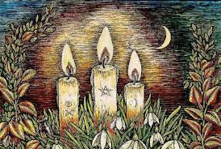

The Book of Common Prayer of the Church in Wales 2004, material from which is included in this service, is copyright © The Representative Body of the Church in Wales.

