St. John the Baptist, Rogerstone
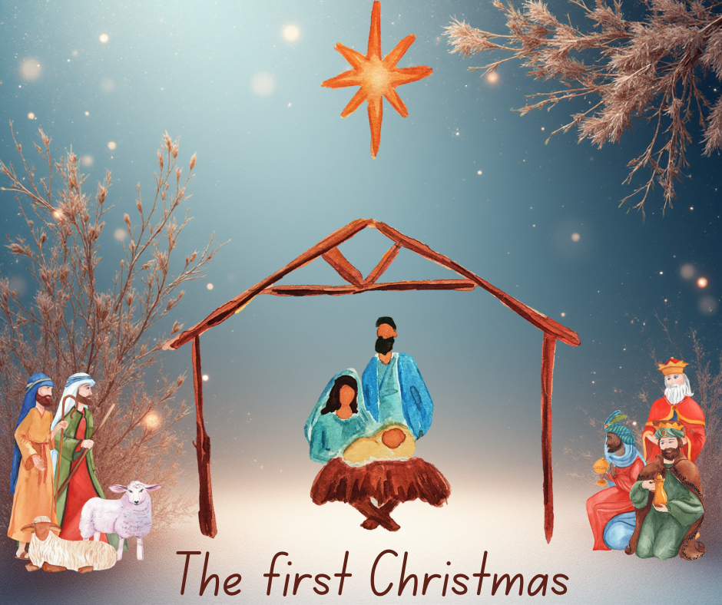

Community Carol Service

Welcome to Church

We hope you enjoy the service today.
We will be using the Bethlehem Carol Sheet during the service; the carol numbers are indicated in (brackets) next to the carols listed below.

Accessibility
During the service, please feel free to stand, kneel or sit as you feel comfortable. Indications of suggested posture and actions are included, in [blue], throughout this booklet but are not mandatory. If you would like to sit for the service, we suggest taking a seat in the front few pews, if you would like to move about during the service we suggest taking a seat towards the back of the church.

If you have any questions or problems during the service please ask a member of our welcome team, who can be found at the back of church near the main entrance.

Please leave this booklet behind at the end of the service.
We are glad you are here.
We want to get to know you.
We want you to know us.
We know God loves us all.
We don’t wish you to hide who you are.
We hope you will want to belong.
We welcome the gifts and talents you bring.

[STAND]

.
Opening Carol (19)
Once in Royal David’s city Omit verses 3+4

[SIT]

INTRODUCTION AND OPENING PRAYER

1st Reading Isaiah 9:2, 6-7 (NRSVA translation)
The people who walked in darkness have seen a great light; those who lived in a land of deep darkness - on them light has shined.
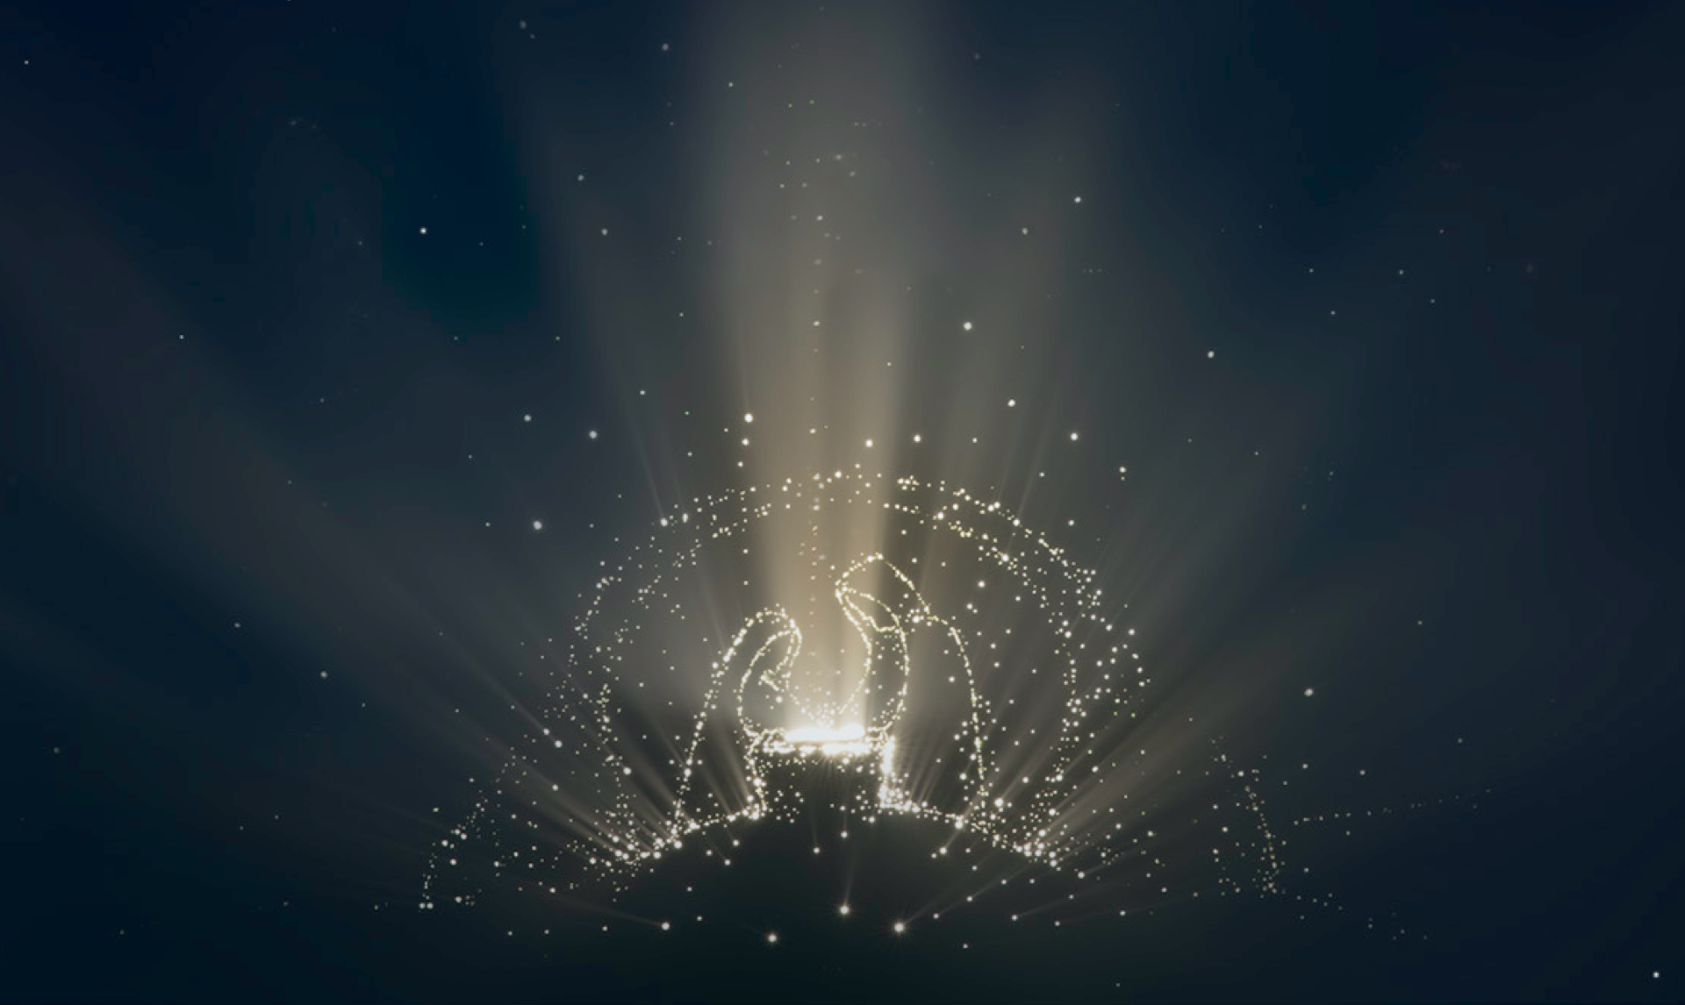
For a child has been born for us, a son given to us; authority rests upon his shoulders; and he is named Wonderful Counsellor, Mighty God, Everlasting Father, Prince of Peace. His authority shall grow continually, and there shall be endless peace for the throne of David and his kingdom. He will establish and uphold it with justice and with righteousness from this time onwards and for evermore. The zeal of the Lord of hosts will do this.

[STAND]

2nd Carol (11) Joy to the World

[SIT]

2nd Reading Micah 5:2-5a (NLT)
But you, O Bethlehem Ephrathah, are only a small village among all the people of Judah. Yet a ruler of Israel, whose origins are in the distant past, will come from you on my behalf. The people of Israel will be abandoned to their enemies until the woman in labour gives birth. Then at last his fellow countrymen will return from exile to their own land. And he will stand to lead his flock with the Lord’s strength, in the majesty of the name of the Lord his God.
Then his people will live there undisturbed, for he will be highly honoured around the world. And he will be the source of peace.
.
[STAND]
3rd Carol (2) In the bleak midwinter
.
[SIT]
3rd Reading Luke 1:26-38 (ICB translation)
During Elizabeth’s sixth month of pregnancy, God sent the angel Gabriel to a virgin who lived in Nazareth, a town in Galilee. She was engaged to marry a man named Joseph

from the family of David. Her name was Mary. The angel came to her and said, “Greetings! The Lord has blessed you and is with you.” But Mary was very confused by what the angel said. Mary wondered, “What does this mean?”
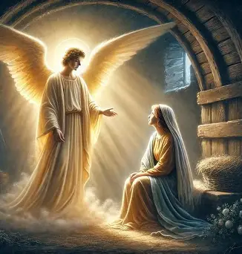
The angel said to her, “Don’t be afraid, Mary, because God is pleased with you. Listen! You will become pregnant. You will give birth to a son, and you will name him Jesus. He will be great, and people will call him the Son of the Most High. The Lord God will give him the
throne of King David, his ancestor. He will rule over the people of Jacob forever. His kingdom will never end.”
Mary said to the angel, “How will this happen? I am a virgin!” The angel said to Mary, “The Holy Spirit will come upon you, and the power of the Most High will cover you. The baby will be holy. He will be called the Son of God. Now listen! Elizabeth, your relative, is very old. But she is also pregnant with a son. Everyone thought she could not have a baby, but she has been pregnant for six months. God can do everything!” Mary said, “I am the servant girl of the Lord. Let this happen to me as you say!” Then the angel went away.

[STAND]
4th Carol (12)
O Come all ye Faithful omit v4
[SIT]
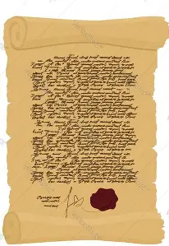
4th Reading Luke 2:1-7 (NIVUK translation)
In those days Caesar Augustus issued a
Decree that a census should be taken of
the entire Roman world. (This was the first
census that took place while Quirinius was
governor of Syria.) And everyone went to
their own town to register.
So Joseph also went up from the town of Nazareth in Galilee to Judea, to Bethlehem the town of David, because he belonged to the house and line of David. He went there to register with Mary, who was pledged to be married to him and was expecting a child. While they were there, the
time came for the baby to be born, and she gave birth to her firstborn, a son. She wrapped him in cloths and placed him in a manger, because there was no guest room available for them.

[STAND]

5th Carol (1) O little town of Bethlehem

[SIT]
5th Reading Luke 2:8-20 (NIVUK translation)
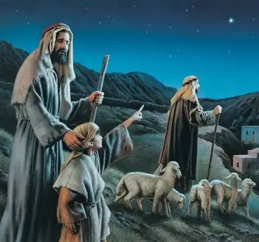
And there were shepherds living out in the fields near by, keeping watch over their flocks at night. An angel of the Lord appeared to them, and the glory of the Lord shone around them, and they were terrified. But the angel said to them, ‘Do not be afraid. I bring you good news that will cause great joy for all the people. Today in the town of David a Saviour has been born to you; he is the Messiah, the Lord. This will be a sign to you: you will find a baby wrapped in cloths and lying in a manger.’
Suddenly a great company of the heavenly
host appeared with the angel, praising God
and saying, ‘Glory to God in the highest heaven, and on earth peace to those on whom his favour rests.’
When the angels had left them and gone into heaven, the shepherds said to one another, ‘Let’s go to Bethlehem and see this thing that has happened, which the Lord has told us about.’

So they hurried off and found Mary and Joseph, and the baby, who was lying in the manger. When they had seen him, they spread the word concerning what had been told them about this child, and all who heard it were amazed at what the shepherds said to them. But Mary treasured up all these things and pondered them in her heart. The shepherds returned, glorifying and praising God for all the things they had heard and seen, which were just as they had been told.
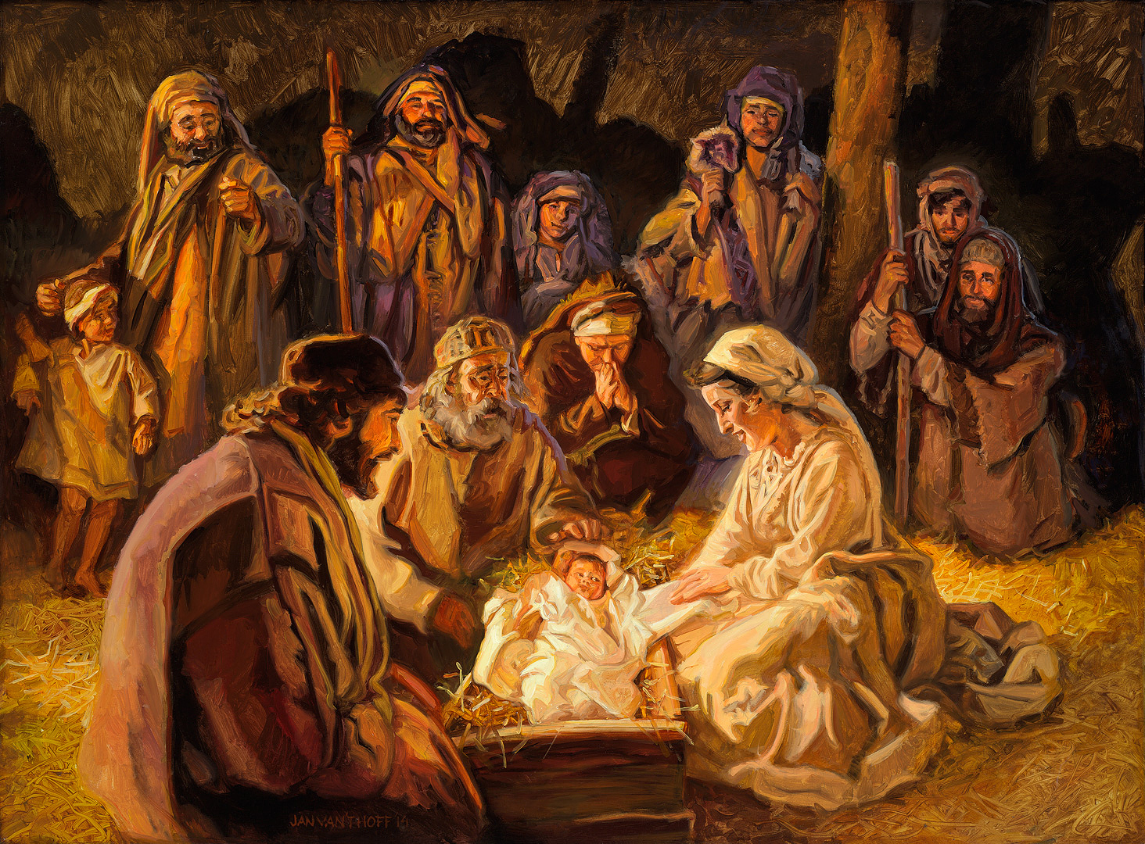
[STAND]
6th Carol (7)
While Shepherds Watched
[SIT]
6th Reading Matthew 2:1-3, 7-11 (TLB translation)
Jesus was born in the town of Bethlehem, in Judea, during the reign of King Herod.
At about that time some astrologers from eastern lands arrived in Jerusalem, asking, “Where is the newborn King of the Jews? for we have seen his star in far-off eastern lands and have come to worship him.” King Herod was deeply disturbed by their question, and all Jerusalem was

filled with rumours. Then Herod sent a private message to the astrologers, asking them to come to see him; at this meeting he found out from them the exact time when they first saw the star. Then he told them, “Go to Bethlehem and search for the child. And when you find him, come back and tell me so that I can go and worship him too!”
After this interview the astrologers started out again. And look! The star appeared to them again, standing over Bethlehem. Their joy knew no bounds!
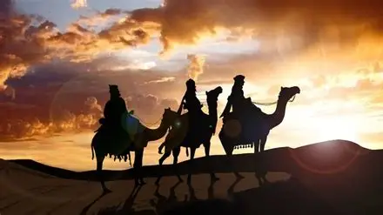
Entering the house where the baby and Mary, his mother, were, they threw themselves down before him, worshiping. Then they opened their presents and gave him gold, frankincense, and myrrh.
[STAND]
7th Carol (21)
We three kings
[SIT]
7th Reading John 1:1-14 (NRSVA translation)
In the beginning was the Word, and the Word was with God, and the Word was God. He was in the beginning with

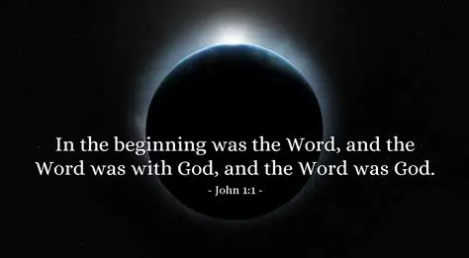
God. All things came into being through
him, and without him not one thing came
into being. What has come into being in
him was life, and the life was the light of all people. The light shines in the darkness, and the darkness did not overcome it.

There was a man sent from God, whose name was John. He came as a witness to testify to the light, so that all might believe through him. He himself was not the light, but he came to testify to the light. The true light, which enlightens everyone, was coming into the world.

He was in the world, and the world came into being through him; yet the world did not know him. He came to what was his own, and his own people did not accept him. But to all who received him, who believed in his name, he gave power to become children of God, who were born, not of blood or of the will of the flesh or of the will of man, but of God.

And the Word became flesh and lived among us, and we have seen his glory, the glory as of a father’s only son, full of grace and truth.


[SIT]
8th Carol (13)
Silent Night


A SHORT TALK

9th Carol (6) Away in a Manger


[SIT OR KNEEL]
PRAYERS
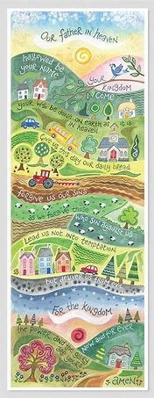
Lord’s Prayer
Our Father, who art in heaven,
hallowed be thy name;
thy kingdom come;
thy will be done;
on earth as it is in heaven.
Give us this day our daily bread.
And forgive us our trespasses,
as we forgive those who trespass against us.
And lead us not into temptation;
but deliver us from evil.
For thine is the kingdom,
the power, and the glory,
for ever and ever. Amen.
© Hannah Dunnett

Announcements and a blessing
May the joy of the angels,
the eagerness of the shepherds,
the perseverance of the wise men,
the obedience of May and Joseph,
and the peace of the Christ Child be yours this Christmas;

and the blessing of God almighty,
the Father, the Son, and the Holy Spirit,
be among you and remain with you always. Amen.

[STAND]
Final Carol (10) Hark the Herald Angels sing

