

The Holy Eucharist

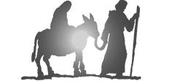

ADVENT

Welcome to Church

We hope you enjoy our service today.
Visiting members of Christian churches are welcome to receive Holy Communion. Adults and children who are not baptised are invited to the altar to receive a blessing during Communion. If you would like a blessing, please keep your hands lowered or bring your service booklet with you.

If you are new to church, please ask for a ‘New to Church booklet which will explain the service in a little more detail. Please also make yourself known to the officiating Priest at the end of the service, we would love to meet you.

Accessibility
During the service, please feel free to stand, kneel or sit as you feel comfortable. Indications of suggested posture and actions are included, in [blue], throughout this booklet. Responses for the congregation can be found in bold.

If you would like a gluten free wafer, or have any additional needs, please ask one of our welcome team when you arrive.

Please leave this booklet behind at the end of the service.
We are glad you are here.
We want to get to know you.
We want you to know us.
We know God loves us all.
We don’t wish you to hide who you are.
We hope you will want to belong.
We welcome the gifts and talents you bring

THE STRUCTURE OF THE SERVICE

1 1. The Gathering Page 3
This is space to come together, and to prepare ourselves, to encounter God in worship, the words of scripture and in the receiving the sacrament.
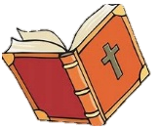
2. The Proclamation of the Word Page 6
When the bible is read aloud in church (words are also printed in the notice sheet), on a Sunday a sermon is also usually preached.

3. The Intercessions Page 9
A time of prayer, when we intercede to God, for ourselves and on behalf others, for the needs of our community and the world.

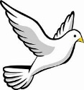
4. The Peace Page 10
As we prepare to receive communion, we receive God’s peace and immediately share it with the gathered community; setting aside any differences we may have before we approach the Lord’s table.

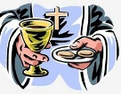
5. The Thanksgiving Page 10
The priest leads the congregation in prayers of thanksgiving, for God’s gifts to us and in particular God’s gift of Jesus, recalling the last supper, Christ’s death on the cross and his resurrection.

- Eucharistic Prayer 2 Page 11

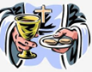
6. The Communion Page 15
Baptised members of the gathered community are invited to approach the altar rail and share in Holy Communion, receiving consecrated bread and wine. For those with a mobility disability, the priest will take Communion to the seat. Non-baptised members are invited to receive a blessing from the Priest at this time.

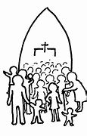
7. The Sending Out Page 16
The conclusion of the service during which the gathered community are sent out to into the world in God’s service, to share God’s love and peace.
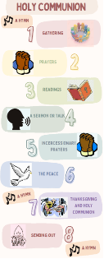

Visual Timetable - Page 19

The Gathering
_____________________________________________________
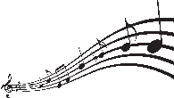
OPENING HYMN

[STAND]
In the name of the Father, and of the Son,
and of the Holy Spirit Amen

To be used up until December 16
From the Christ who was, who is, and who is to come:
Grace and peace be with you all. And also with you.

To be used from December 17
May the grace and peace of our Lord Jesus Christ, who is coming into the world, be with you. And also with you.

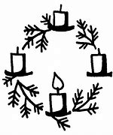

LIGHTING THE ADVENT CANDLES

[SIT]

[To be used on 1st Sunday of Advent]
Hurry, Lord Jesus, and come to us quickly:
fill our hearts with excitement at your coming into the world.
May your ancient promises fulfil the hopes of everyone on earth. Amen. Come, Lord Jesus

[To be used on 2nd Sunday of Advent]
Hurry, Lord Jesus, and come to us quickly:
fill our hearts with praise at your coming into the world.
May the message of the prophets reach the ears of everyone on earth. Amen. Come, Lord Jesus

To be used on 3rd Sunday of Advent
Hurry, Lord Jesus and come to us quickly:
fill our hearts with joy at your coming into the world.
May the words of John the Baptist
open the hearts of everyone on earth.
Amen. Come, Lord Jesus

To be used on 4th Sunday of Advent
Hurry, Lord Jesus, and come to us quickly:
fill our hearts with awe at your coming into the world.
May the joy of Mary fill the lives of everyone on earth.
Amen. Come, Lord Jesus

[Say together]
Father of glory, holy and eternal,
look upon us now in power and mercy.
May your strength overcome our weakness,
your radiance transform our blindness,
and your Spirit draw us to that love
shown and offered to us by your Son,
our Saviour Jesus Christ. Amen.

[To be used up until December 16]
My brothers and sisters,
let us be alert to the advent of God
and prepare the Lord’s way by turning from sin,
embracing justice and truth,
and finding comfort in the Christ who promises peace.

[To be used from December 17]
My brothers and sisters,
as the dawn of Christ’s coming breaks into our lives,
let us turn away from the darkness of sin
that the radiance of God’s love will shine upon us.


A CHANCE TO BRING OUR SINS BEFORE GOD

[KNEEL OR SIT]
Lord, have mercy. Lord, have mercy.
Christ, have mercy. Christ, have mercy.
Lord, have mercy. Lord, have mercy.

Silence

Let us bring our sins to our Heavenly Father:
Heavenly Father,
we have sinned in thought, word and deed,
and have failed to do what we ought to have done.
We are sorry and truly repent.
For the sake of your Son Jesus Christ who died for us,
forgive us all that is past and lead us in his way
to walk as children of light.
Amen.


Almighty God, who forgives all who truly repent,
have mercy on you and set you free from sin,
strengthen you in goodness and keep you in eternal life; through Jesus Christ our Lord. Amen.


THE COLLECT OF THE DAY

The Priest introduces a period of silence with the words:

Let us pray that we may be ready for the coming of Christ.

The Collect prayer can be found in the notice sheet and is said by the priest, all respond, Amen.

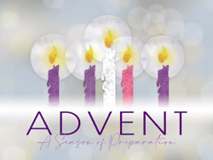

2. The Proclamation of the Word
_____________________________________________________

A copy of the readings can be found on the notice sheet (please ask if you need a large print copy).

[ SIT ]
The First Reading

At the end the reader says:

Either: This is the word of the Lord.
Thanks be to God.

or: Hear what the Spirit is saying to the church.
Thanks be to God.

A Psalm or Canticle
The psalm can be found on the weekly notice sheet, it may include a response for the congregation. Please check the sheet for details.

The Second Reading

At the end the reader says:

Either: This is the word of the Lord.
Thanks be to God.

or: Hear what the Spirit is saying to the church.
Thanks be to God.

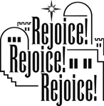
THE GOSPEL READING

[ STAND ]
The Gospel Acclamation
The gospel acclamation can be found on the notice sheet.
The priest or deacon read the acclamation and the congregation responds.

The Gospel

The reader says:
Listen to the Gospel of Christ according to Saint....
Glory to you, O Lord.

After the Gospel:
This is the Gospel of the Lord.
Praise to you, O Christ.


THE SERMON

[ SIT ]

AN AFFIRMATION OF THE FAITH – The Nicene Creed

[STAND]
We believe in one God,
the Father, the almighty, maker of heaven and earth,
of all that is, seen and unseen.

We believe in one Lord, Jesus Christ, the only Son of God,
eternally begotten of the Father,
God from God, Light from Light,

true God from true God, begotten, not made,
of one Being with the Father.

Through him all things were made.
For us and for our salvation
he came down from heaven;
by the power of the Holy Spirit
he became incarnate from the Virgin Mary, and was made man.

For our sake he was crucified under Pontius Pilate;
he suffered death and was buried.
On the third day he rose again
in accordance with the Scriptures;
he ascended into heaven
and is seated at the right hand of the Father.
He will come again in glory to judge the living and the dead,
and his kingdom will have no end.

We believe in the Holy Spirit, the Lord, the giver of life,
who proceeds from the Father and the Son,
who with the Father and the Son
is worshipped and glorified,
who has spoken through the prophets.

We believe in one holy catholic and apostolic Church.
We acknowledge one baptism for the forgiveness of sins.
We look for the resurrection of the dead,
and the life of the world to come. Amen.

3 The Intercessions
_____________________________________________________

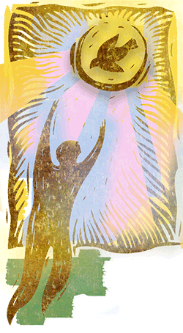
[SIT / KNEEL]

After each intercession:
Either: Lord, in your mercy,
hear our prayer.

or: Let us pray to the Lord.
Lord, have mercy.

or: Lord, raise up your power,
and come among us.

After the final prayer:

Either: or:
Merciful Father, Let us commend ourselves,
accept these prayers and one another and all our
for the sake of your Son, life to Christ our God.
our Saviour Jesus Christ. Holy God, holy and strong,
Amen. holy and immortal
have mercy on us.

This prayer may follow:
Lord Jesus Christ,
you draw us and welcome us,
emptied of pride and hungry for your grace,
to this your kingdom feast.
Nowhere can we find the food
for which our souls cry out,
but here, Lord, at your table.
Invigorate and nourish us, good Lord,
that in and through this bread and wine
your love may meet us
and your life complete us
in the power and glory of your kingdom. Amen.
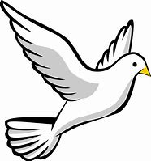
4. The Peace

[STAND]
_____________________________________________________

Either:
In the tender compassion of our God
the dawn from heaven will break upon us,
to shine on those who live in darkness,
under the shadow of death,
and to guide our feet into the way of peace.

or: May the God of peace make you completely holy,
ready for the coming of our Lord Jesus Christ.

The peace of the Lord be with you always.
And also with you.

A sign of peace may be exchanged.

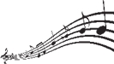
OFFERTORY HYMN
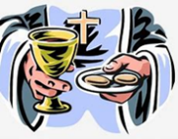
5. The Thanksgiving

_____________________________________________________
The priest takes the bread and the cup and may say:

We celebrate the gifts and grace of God
We take this bread, we take this wine
to follow Christ’s example and obey his command.

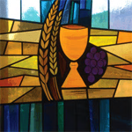
EUCHARISTIC PRAYER 2

The Lord be with you.
And also with you.

Lift up your hearts.
We lift them to the Lord.

Let us give thanks to the Lord our God.
It is right to give our thanks and praise.

True and living God, the source of life for all creation,
you have made us in your own image.
Always and everywhere we give you thanks
through Jesus Christ our Lord.

[Up until December 16]
In many and various ways
you have spoken to us through the prophets.
In these days you have spoken to us through your Son,
our merciful and faithful high priest,
the heir of all things
through whom you made the world.
He is the brightness of your glory
and sits at your right hand in majesty
from where he will come to judge the living and the dead

[From December 17]
The prophets prepared us for his coming, the Blessed Virgin Mary longed for him with love beyond all telling.
At the presence of Jesus, John the Baptist danced in his mother’s womb and proclaimed his advent when at last he came.
Already we rejoice in his birth,
for he has given us the gift of grace,
that he may find us watchful and waiting,


Therefore, with angels and archangels
and with all the company of heaven
we praise your glorious name:

Holy, holy, holy Lord,
God of power and might,
heaven and earth are full of your glory.
Hosanna in the highest.

Blessed is he who comes in the name of the Lord.
Hosanna in the highest.

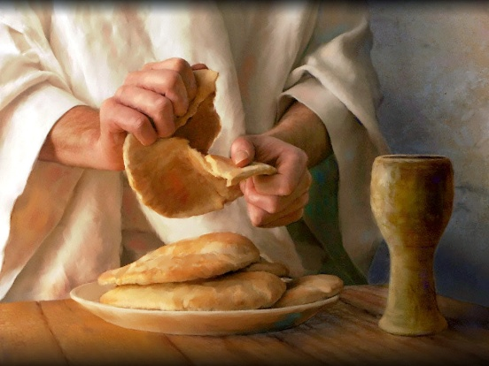
Blessed are you, almighty God,
because on the night he was betrayed
the Lord Jesus took bread,
and when he had given you thanks,
he broke it, gave it to his disciples
and said,Take, eat; this is my body
which is given for you:
do this in remembrance of me.

In the same way, after supper he took the cup;
when he had given you thanks he gave it to them and said,
Drink this, all of you;
this cup is the new covenant in my blood
poured out for you and for many
for the forgiveness of sins:
do this as often as you drink it in remembrance of me.

Great is the mystery of faith:
Christ has died.
Christ is risen.
Christ will come in glory.

Therefore, loving God,
recalling now the sacrifice of Christ your Son
once for all upon the cross
and the triumph of his resurrection,
we ask you to accept this our sacrifice of praise.

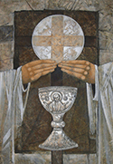
Send your Holy Spirit
on us and on these gifts
that we may be fed with
the body and blood of your Son
and be filled with your life
and goodness.
Unite us in Christ
and give us your peace
that we may do your work
and be his body in the world.

Through him, with him, in him,
in the unity of the Holy Spirit
all honour and glory are yours, almighty Father,
for ever and ever.
Amen.

Silence.

[SIT or KNEEL]

THE LORD’S PRAYER

Either: As our Saviour taught us, we boldly pray:
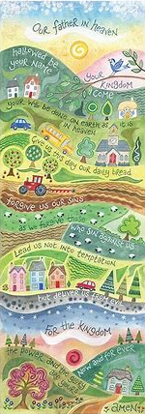
Our Father who art in heaven,
hallowed be thy name,
thy kingdom come, thy will be done,
on earth as it is in heaven.
Give us this day our daily bread.
And forgive us our trespasses
as we forgive those
who trespass against us.
And lead us not into temptation,
but deliver us from evil.
For thine is the kingdom,
the power and the glory,
© Hannah Dunnett for ever and ever. Amen.

or: Let us pray with confidence to the Father:
Our Father in heaven,
hallowed be your name,
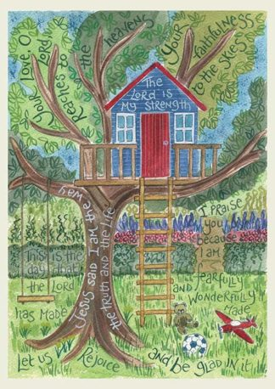
your kingdom come,
your will be done,
on earth as in heaven.
Give us today our daily bread.
Forgive us our sins
as we forgive those who sin against us.
Save us from the time of trial
and deliver us from evil. © Hannah Dunnett
For the kingdom, the power
and the glory are yours,
now and for ever. Amen.

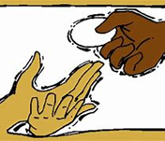
6. The Communion
_____________________________________________________

The priest breaks the bread.

Every time we eat this bread and drink of this cup
we proclaim the Lord’s death until he comes.

Either: Jesus, Lamb of God: have mercy on us.
Jesus, bearer of our sins: have mercy on us.
Jesus, redeemer of the world: give us your peace.

or: Lamb of God, you take away the sins of the world:
have mercy on us.
Lamb of God, you take away the sins of the world:
have mercy on us.
Lamb of God, you take away the sins of the world:
grant us peace.

The priest invites the people to communion:

Come, let us receive the body and blood of our Lord Jesus Christ, given for us, and feed on him in our hearts by faith with thanksgiving.


The priest and people receive communion or a blessing.
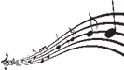
During communion hymns may be sung.

After the communion a period of silent reflection is kept
ending with a Collect prayer.

Notices may be given.
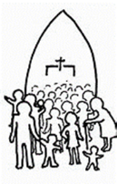
7. The Sending Out
_____________________________________________________

[STAND]
Give thanks to the Lord for he is gracious:
his love is everlasting.

Generous God,
you have fed us at your heavenly table.
Kindle us with the fire of your Spirit
that when the Lord comes again
we may shine as lights before him,
who is alive and reigns
in glory for ever. Amen.

The Lord be with you.
And also with you.

Either: Christ the Sun of righteousness shine on you
and scatter the darkness from before you.

or: May God the Father, judge all merciful,
make us worthy of a place in his kingdom. Amen.
May God the Son, coming among us in power,
reveal in our midst the promise of his glory. Amen.
May God the Holy Spirit make us steadfast in faith,
joyful in hope and constant in love. Amen.

And the blessing of God almighty,
the Father, the Son, and the Holy Spirit,
be among you and remain with you always. Amen.

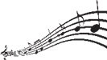 FINAL HYMN

Go in peace to love and serve the Lord.
In the name of Christ. Amen.
Blank Page

Blank Page

The Book of Common Prayer of the Church in Wales 2004, material from which is included in this service, is copyright © The Representative Body of the Church in Wales.

