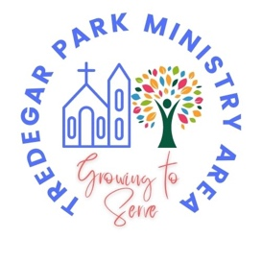
Events: February

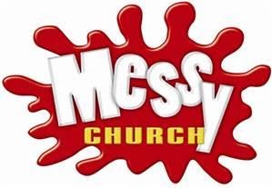 | Messy Church  The next Messy Church is at St. Thomas’ Church, Maesglas on Sunday 1st February between 3pm and 5pm.  Messy Church is a great way to do church as a family, with plenty of activities, storytelling and singing, finishing up with a light tea (all free). We'd love to welcome you!!!  Check out our @TredegarParkMinistryArea YouTube channel for a sneak peak of what we get up to.
 | Community Coffee  Everybody is welcome to join us at one of our community coffee mornings.  We meet on the first Saturday of every month at St. John’s Church, Rogerstone between 10.30am and 12.00pm.  We also meet every Thursday at St. Basil’s Church Hall, Bassaleg between 10.30am and 12.00pm.
 | Mothers’ Union  Bassaleg Mother’s Union meets in St. Basil’s Hall at 2.30pm on the second and fourth Tuesday of each month. Rogerstone Mothers’ Union meets on the second Tuesday of the month at 2pm in St. John’s.
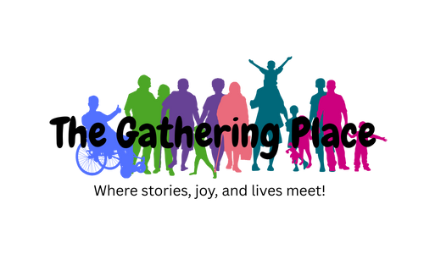 | The Gathering Place  You are invited to join us for 'The Gathering Place' an informal contemporary worshipping community which meets monthly on the last Sunday of each month. Please refer to the weekly notices for details of February’s service.  Join us for a breakfast with hot drinks, pastries and toast, from 9.30am (totally free). A joyful and uplifting worship service then begins at 10.30am.  People of all ages are welcome, the Gathering Place is especially aimed at those who are new to church, and creative explorers of faith and spirituality.  Check out our @TredegarParkMinistryArea YouTube channel to see previous ‘The Gathering Place’ services.
 | Alpha Courses  Bring your own questions about life, faith and spirituality to our new Alpha course, running fortnightly between January and June on Wednesday evenings (term-time) at St Thomas' Church, Maesglas.  Sessions usually start with a game and free food and time to get to know each other. Then watch a talk that unpacks a big question around life, purpose, and the Christian faith. Share your thoughts if you want to, and hear from others. You can say anything you like or nothing at all. We'd love to meet you!  Youth Course (ages 10+): 5.30-7.00pm on 4th February; 4th& 18th March; 15th & 29th April; 13th& 27th May and 3rd June.  Adult Course: 7.00-8.30pm on 28th January; 11th & 25th February; 11th & 25th March; 22nd April, 6th & 20th May and 3rd June.  Book a place on our Tredegar Park Ministry Area website or just pop along.
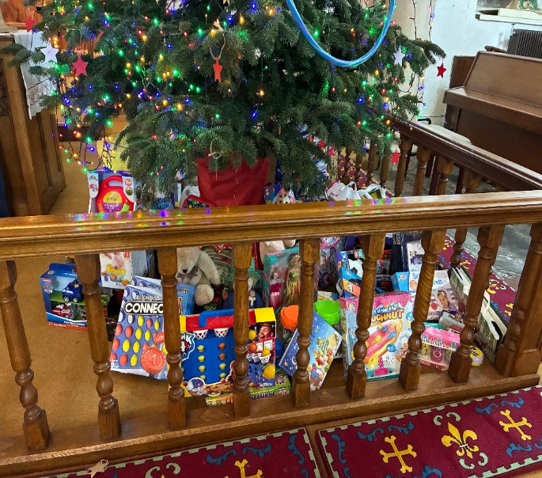     | St Basil’s Toy Appeal 2025  (as part of Tredegar Park Ministry Area)  On behalf of Raven House Trust and St Basil’s church we would like to “Thank you” all for continuing to support this worthwhile cause and enriching the lives of children in the Newport area.  This year we raised nearly 250 presents. These were all collected in St Basils before distribution to RHT in time for allocation to various organisations throughout the Newport area in plenty of time to be distributed before Christmas.  It was lovely to be invited to RHT for their Christmas event where children, identified by schools and also other relevant groups were invited to RHT to meet Santa and be given presents that they may not otherwise receive.  The joy on their faces was a lovely experience. Once again many, many thanks to other churches in the Ministry Area and members of the local community for your continued contribution and support.  Eleanor, on behalf of The St Basil’s Toy Appeal.

